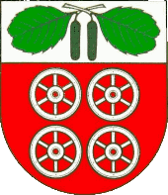
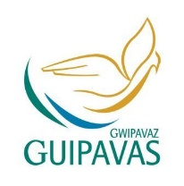
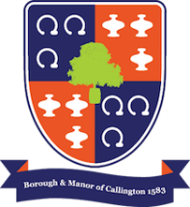

Callington & District Twinning Association
Twinned with Guipavas, Brittany since 1982
and Barsbüttel, Germany since 2004

Chairman: Sue Lumley Secretary: Ken Aspinall
23 Launceston Road 5 Fowey Crescent
Callington Callington
Cornwall Cornwall
PL17 7BT PL17 7PJ

01579 382705 01579 383135

Living amongst European friends
Callington Twinning Association is delighted to have the opportunity to work in partnership with Callington Community College on an exciting project involving some 60 young people and accompanying adults from five different communities across Europe.
In the summer of 2020, from 27th July to 5th August, a large, residential Youth Project is planned in Barsbüttel, one of Callington’s twin towns. It will be based in the Barsbüttel Community College and will be underwritten by Barsbüttel Town Council.

Those taking part will be young people from each of Barsbüttel’s four twin towns: Callington in England, Guipavas in France, Keila in Estonia and Graal-Müritz, a German town on the Baltic Sea which was previously part of the former East Germany.
You can be there too! Will you be between 15 and 18 years of age by the end of August 2020? Then why not join in? Apply now for one of a dozen places reserved for students from Callington!
What awaits you?
It's all about sharing and building friendships in the partner communities. Some 60 young people, alongside numerous supervisors from the five communities, will take part in the Camp. You will spend time with like-minded young people making music, enjoying sport and generally living and eating together, exchanging thoughts and opinions, hopes and aspirations.

Accommodation will be provided in the local Community College, where you will also eat and have recreational facilities
Great trips are planned, e.g. to the cities of Hamburg and Kiel and to the Baltic coast.
You will be taking part in small-group forums, discussing a range of topics relevant to young people’s role in Europe of the future.
There is no limit to the range of questions and topics that we will be able to discuss. A diverse, dynamic and imaginative exchange of ideas will be possible in small-group discussions and will be presented creatively to conclude the week’s activities.

Travel

Travel will be by National Express from Plymouth to Gatwick Airport with a direct two-hour flight to Hamburg. We will be collected by our hosts and transported by coach to the centre in Barsbüttel, about an hour’s journey.

Travel insurance will be provided by the organisers, but you will need an up-to-date passport and a current EHIC card, available free-of-charge on-line and still applicable until the end of 2020.

What will it cost?
The cost of food and accommodation and of all bus excursions and other activities will be paid for by Barsbüttel Town Council. You only have to contribute towards your travel costs and any other incidentals (e.g. pocket money etc.). Grant-funding from Callington & District Twinning Association and the Twinning Committee for Cornwall should limit the individual costs to no more the £60 for return travel to and from Callington.

The organisers hope to arrange a number of team-building activities before your departure (such as car boot sales, cake sales or other ideas that you may have) which could help to offset the travel costs.

Why should you take part?
- Don't miss out on the opportunity of this exciting camp with young people from all
over Europe!
- Learn to understand the views of others.
- Experience Europe on the inside!
Be assured that, in addition to the discussions, the central theme at the forefront of the week will be having fun together with people of your own age. And you might just learn or practise a few elements of a new language! You will certainly make new friends.

You can also email any questions to callingtontwinning@gmail.com

Clearly, parents will be invited to an information evening and kept abreast of the project as it develops.

To register your interest in this project, please return the reply slip to callingtontwinning@gmail.com by Monday 16th March.

Yours sincerely

Sue Lumley
Chairman
RESIDENTIAL YOUTH PROJECT IN GERMANY
27th July – 5th August

I would like to be considered for the 2020 Youth Project in Germany

Name: ……………………………………………………………………………………………………………………….

Telephone: …………………………………

Age by the end of August 2020: …... years and ……. months

